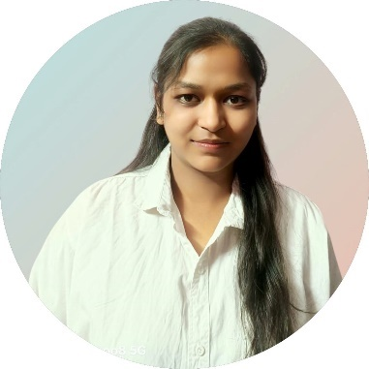 final resume1.docx

Nancy Aggarwal

**Email ID: nancy2501st@gmail.com**

**Mobile: +91-7976252874**

**LinkedIn:** [**www.linkedin.com/in/nancy-aggarwal-3b8699346**](http://www.linkedin.com/in/nancy-aggarwal-3b8699346)

**OBJECTIVE**

A passionate and driven B.Tech Computer Science student with strong programming, database management, and web development skills. Seeking opportunities to apply my technical abilities in software development, web development or data management while contributing to social impact initiatives.

**Skills**

* Technical Skills: JAVA, C++, DBMS, HTML, CSS , JavaScript, MS EXCEL, MS Word, Power Point Prestation, Spreadsheet
* Behavioral Skills: Leadership, Team Player

**Education**

* 2022-2026 B.TECH in *Computer Science* from Jecrc Engireeing College and Research Centre , Jaipur, Rajasthan with 7.8 CGPA. 2024 (complete with vth semester ).
* 12th from MDVM (Parle) School, Neemrana, Rajasthan with 70%marks.
* 10th from MDVM (Parle) School, Neemrana, Rajasthan with 58.7% marks.

**TRANING and CERTIFICATIONS**

* TRANING From UPFLAIRS
* Certificate SKILLS: C, HTML, Java, Government Savidana

**Projects**

* To Make a portfolio
* TO MAKE A REAL PROJECT ON DASHBOARD

**INTERESTS, HOBBIES**

* Badmintion
* Sketching5